# Chapter 5 Homework – John Paukovits

1. What are the essential parts of the counter-controlled iteration?
   1. The essential parts of the counter are the:
      1. Control variable
      2. Initial Value
      3. Increment
      4. Loop continuation condition
2. Which Java loop statement is best for counter-controlled iteration?
   1. The **for** statement is typically used for counter-controlled iteration.
3. Write a for statement that varies the control variable from 48 to 4 in decrements of 4.
   1. 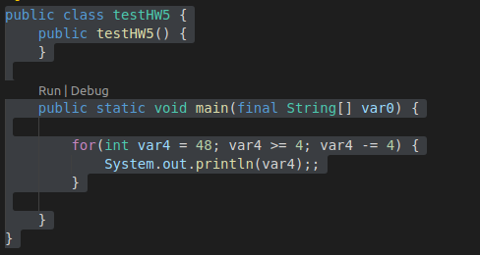
4. What is the difference between a while statement and a do...while statement?
   1. A while loop tests the loop-continuation condition at the beginning of the loop, before executing the loop’s body. The do…while statement tests the loop-continuation condition after executing the loop’s body; therefore, the body always executes at least once.
5. What is the difference between the break statement and the continue statement when executed within a loop?
   1. The break statement will exit a loop completely while the continue statement will skip that iteration.